**Ridhima Joshi**

**Varshithanand Kotipalli**

SWEN5232 - Software Construction

Assignment Number: 9

Professor: Dr. Findler

[findler@uhcl.edu](mailto:findler@uhcl.edu)

Teaching Assistant:

Shail Panchal

**Component Diagrams**

**Woodwork Tools**

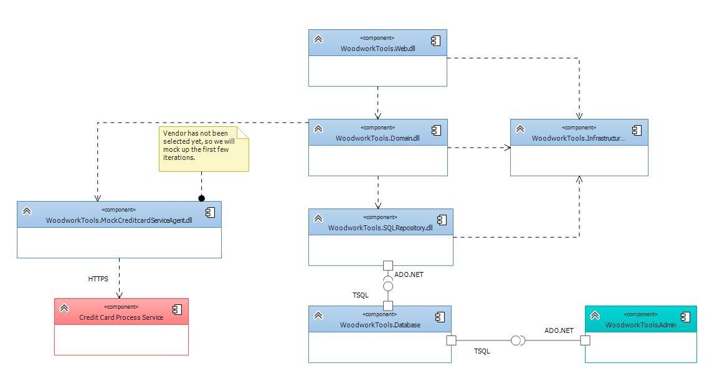

Figure 1: Component Diagram for Woodwork Tools

**Coffee shop**

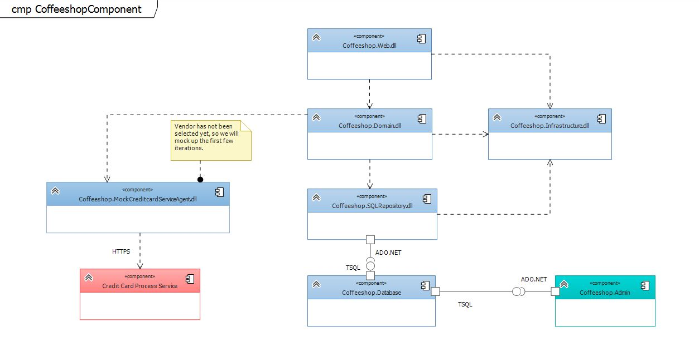

Figure 2: Component Diagram for Coffee Shop

**Question:**

____________ can also be drawn in the form of class diagram.

1. Deployment Diagram
2. Package Diagram
3. Component Diagram
4. Object Diagram

Correct Answer: c) Component Diagram

Page No. 140

Component diagram can be drawn in the form of class diagram as they focus on the dependencies between the components.